START | “I Hope all your Christmases will be very merrily.” Explain what the grammatical error is and correct it. | Find and correct the mistake: “Oh, the whether outside is frightful, but the fire is so delightful, and since we’ve no place to go, let it snow, let it snow, let it snow.” | In Harry Potter and the Philosopher’s Stone, what priceless thing does Harry get for Christmas from an unknown giver? | What is the title of the film in which Jack Skellington is bored with Halloween? |  | Which famous Christmas song includes the lyrics: “Dashing through the snow, in a one-horse open sleigh?” | In Disney’s Juleshow, which character sings the song “When You Wish upon a Star”? | 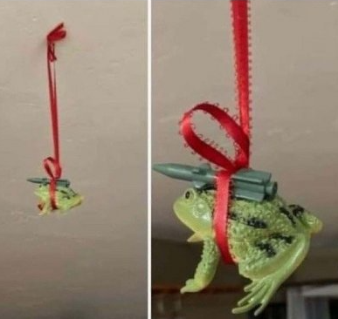  What is this? | Complete the sentence: “’Twas the night before Christmas, when all through the house not a creature was stirring, not even a …” | Which character in Harry Potter says that he always gets books for Christmas instead of the socks that he actually wants?
In which year was “Do They Know It’s Christmas?” recorded? (check with teacher) | What is grammatically wrong with the phrase “Santas Little Helper”? | What is the name of the tower in Die Hard, in which Hans Gruber takes hostages? | “When school ends, will I start my holiday.” Correct the mistake and explain. | In which country did the tradition of the Christmas tree begin? |  | What is the name of the main character in A Muppet Christmas Carol? | Which American holiday was “Jingle Bells” actually written for? | What is the name of the Christmas song that begins,  “On the first day of Christmas my true love gave to me a partridge in a pear tree.”? | Name the date on which Brits/Americans celebrate Christmas. | What is the title of the 1984 Christmas hit by Wham? | “I not like Christmas.” Correct the sentence and explain what’s wrong.
 | Who told the shepherds about the birth of Jesus? | In which book has the white witch cast a spell to make it “always winter but never Christmas”? | At Christmas you may kiss anyone standing under which plant? | Where do Americans wrongly think that Santa Claus lives? | “Deck the halls with boughs of holly …”  How does the song continue? |  | What is the English word for “julekugle”? (check with teacher) | In the Disney film Bambi, what is Bambi’s problem when Thumper takes him out on the ice? | Which tv-cartoon family has a dog called Santa’s Little Helper? |  | What is the name of Kristoff's reindeer in Frozen?
According to tradition, how does Santa Claus get into people’s houses? |  | MERRY  CHRISTMAS! | What should you leave on a plate for Santa on Christmas night? 70 | Continue the song: “All I want for Christmas …” | Name five things to eat for Christmas (in English, of course) | What is the religious name of Father Christmas? |  | What is the English word for “Lametta” (the silvery stuff in long ribbons that you hang on the Christmas tree)? (Check with teacher) | How many days of Christmas are there? | Who sings the Christmas hit “Underneath the Mistletoe” from 2011? | What was the first company that used Santa Claus in advertising?
What is the 26th of December called in Britain? | In what town was Jesus born? | What is the English version of the Danish Christmas carol “Glade Jul” called? | Correct and explain: “People has bought many presents.” | Name five Christmas traditions | According to Danish tradition, where does Santa live? |  | Who has joined Ed Sheeran to make a 2021 Christmas hit? | What do children who have been naughty get in their Christmas stockings according to tradition? | Which singer is always “Driving Home for Christmas”? | What is the name of Jesus’ mother? | Correct and explain: “They isn’t coming home for Christmas”
The Danish word ”jul” can be translated into English in two ways. Name them. | Correct and explain: “The Virgin Mary was the women who gave birth to Jesus.” | In the film The Holiday, Iris goes from England to which American City for Christmas? |  | Name five things to hang on a Christmas tree (in English) | In which American city does Die Hard take place? | On which date did the Holy Ghost tell Mary that she was pregnant with Jesus? | In which Christmas film did Donald Trump have a cameo? | “But all around are all the little rats. And the Scots, and the Scots.”  Which Danish Christmas song is this a bad translation of? |  | How many magi (vise mænd) visit little baby Jesus with gifts? | Which kind of animal is Rudolph?

